Geometry: Unit 9, Lesson 5
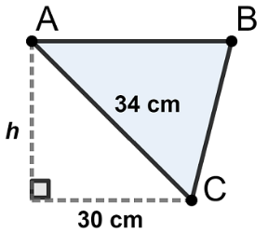
- What is the height of $∆ABC$?

$$16 cm$$

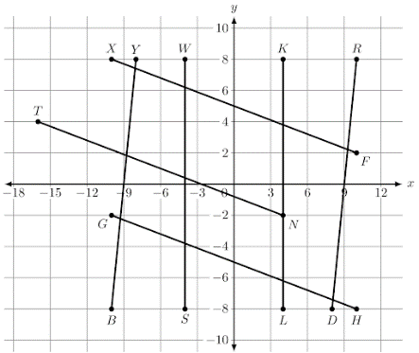
- Line segments $\overline{YB}$, $\overline{RD}$, $\overline{XF}$, $\overline{GH}$, $\overline{WS}$, $\overline{KL}$, and $\overline{TN}$ are shown on the coordinate grid. What is an example of two parallel line segments?

$$\overline{RD}∥\overline{YB}$$

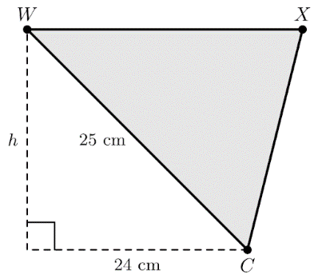
- Triangle $WXC$ is shown where $WC=25$ centimeters $(cm)$. The base length of $24 cm$ is shown for the corresponding right angle triangle. What is the value of $h$?

$$h=7 cm$$

